Lab: Iterators and Comparators
Problems for exercises and homework for the "CSharp Advanced" course @ Software University.
You can check your solutions here: https://judge.softuni.bg/Contests/1489/Iterators-and-Comparators-Lab

Library
NOTE: You need the namespace IteratorsAndComparators.
Create a class Book, which should have three public properties:
- string Title
- int Year
- List<string> Authors
Authors can be anonymous, one or many. A Book should have only one constructor.
Create a class Library, which should store a collection of books and implement the IEnumerable<Book> interface.
- List<Book> books
A Library could be intilized without books or with any number of books and should have only one constructor.

Examples
StartUp.cs
public static void Main()
{
Book bookOne = new Book("Animal Farm", 2003, "George Orwell");
Book bookTwo = new Book("The Documents in the Case", 2002, "Dorothy Sayers", "Robert Eustace");
Book bookThree = new Book("The Documents in the Case", 1930);

Library libraryOne = new Library();
Library libraryTwo = new Library(bookOne, bookTwo, bookThree);
}

Solution
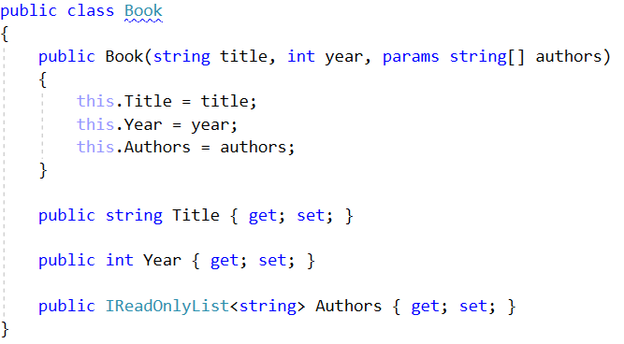
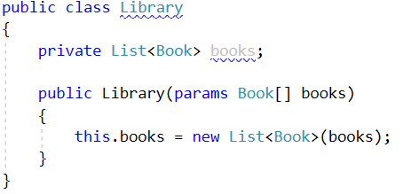

Library Iterator
NOTE: You need the namespace IteratorsAndComparators.
Extend your solution from the prevoius task. Inside the Library class create a nested class LibraryIterator, which should implement the IEnumerator<Book> interface. Try to implement the bodies of the inherited methods by yourself. You will need two more members:
- List<Book> books
- int currentIndex
Now you should be able to iterate through a Library in the Main method.

Examples
Startup.cs
public static void Main()
{
Book bookOne = new Book("Animal Farm", 2003, "George Orwell");
Book bookTwo = new Book("The Documents in the Case", 2002, "Dorothy Sayers", "Robert Eustace");
Book bookThree = new Book("The Documents in the Case", 1930);

Library libraryOne = new Library();
Library libraryTwo = new Library(bookOne, bookTwo, bookThree);

foreach (var book in libraryTwo)
{
Console.WriteLine(book.Title);
}
}

Output
Animal Farm
The Documents in the Case
The Documents in the Case

Solution
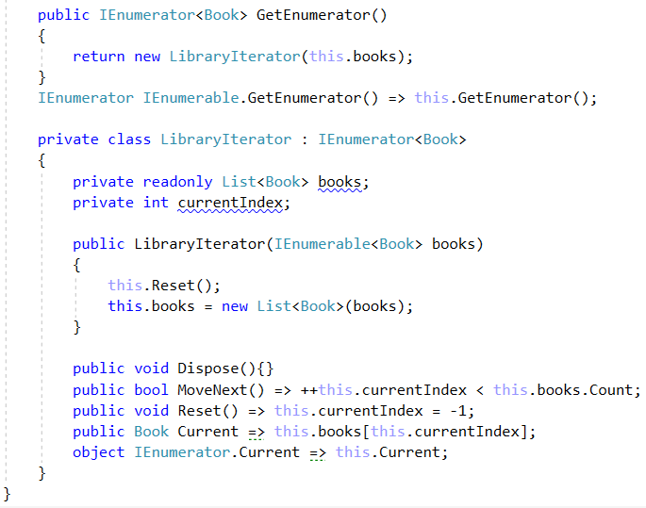

Comparable Book
NOTE: You need the namespace IteratorsAndComparators.
Extend your solution from the prevoius task. Implement the IComparable<Book> interface in the existing class Book. The comparison between two books should happen in the following order:
- First sort them in ascending chronological order (by year)
- If two books are published in the same year, sort them alphabetically
Override the ToString() method in your Book class, so it returns a string in the format:
- "{title} - {year}"
Change your Library class, so that it stores the books in the correct order.

Examples
Startup.cs
public static void Main()
{
Book bookOne = new Book("Animal Farm", 2003, "George Orwell");
Book bookTwo = new Book("The Documents in the Case", 2002, "Dorothy Sayers", "Robert Eustace");
Book bookThree = new Book("The Documents in the Case", 1930);

Library libraryOne = new Library();
Library libraryTwo = new Library(bookOne, bookTwo, bookThree);

foreach (var book in libraryTwo)
{
Console.WriteLine(book);
}
}

Examples
Output
The Documents in the Case - 1930
The Documents in the Case - 2002
Animal Farm - 2003

Solution
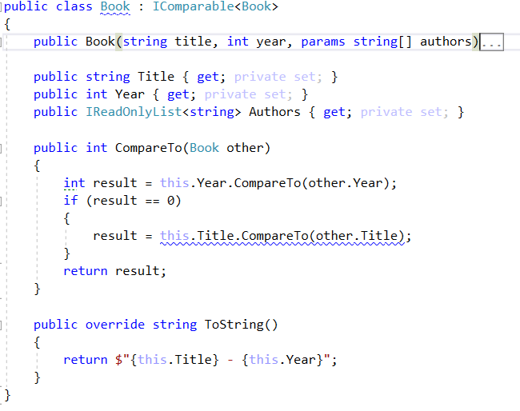

Book Comparator
NOTE: You need the namespace IteratorsAndComparators.
Extend your solution from the prevoius task. Create a class BookComparator, which should implement the IComparer<Book> interface and thus include the following method:
- int Compare(Book, Book)
BookComparator must compare two books by:
- Book title - alphabetical order
- Year of publishing a book - from the newest to the oldest
Modify your Library class once again to implement the new sorting.

Examples
Startup.cs
public static void Main()
{
Book bookOne = new Book("Animal Farm", 2003, "George Orwell");
Book bookTwo = new Book("The Documents in the Case", 2002, "Dorothy Sayers", "Robert Eustace");
Book bookThree = new Book("The Documents in the Case", 1930);

Library library = new Library(bookOne, bookTwo, bookThree);
}

Output
Animal Farm - 2003
The Documents in the Case - 2002
The Documents in the Case - 1930

Solution
